Track and Field 2022
(Boys and Girls)
Hello Track and Field Athletes
(Action Items are highlighted)
It is time to start thinking about Track and Field for Spring 2022. I am excited to be back to our normal type of season and normal timeline. For our Seniors, they may remember what this looks like. The rest of you will experience “Track and Field as Usual” for the first time.
Please share this email with potential track athletes! Especially Freshmen!
Important dates
- Season Starts on March 7!
- Season Ends with State Meet on June 3-4.
- Spring Break is the Week of March 21-25.
- There will be Indoor Meets again!
All Athletes should follow this link or QR Code and complete the form to sign up.
https://tinyurl.com/oldabetrack2022 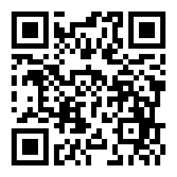
All Athletes and Parents should use the following code to sign up for the Remind service at Remind.com
Remind.com is a service that allows me to anonymously send and receive text messages and reminders. No cell numbers are revealed in the process. Our group is a closed group, so no one outside the program can contact you.
Class | Remind Code
Freshmen | kh6ed7
Sophomore | f2d77f
Juniors | 9kcg76
Seniors | g638b7

