Art for Week of: April 27-May 1
Choose one (or both!) options below to explore SHAPE. I would love to see what you create! Feel free to send me a picture by email, cledin@ecasd.us, or through a Microsoft Teams Chat if you have your school iPad at home.
THIS WEEKS ELEMENT OF ART SHAPE
SHAPE: A dot that goes for a walk and goes back to the starting point.
There are two types of shapes: ORGANIC and GEOMETRIC. We find organic shapes in nature and geometric shapes are shapes you can name and you learn about in math.
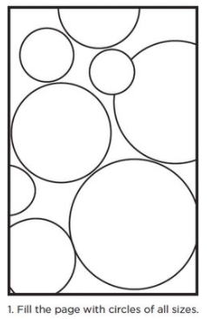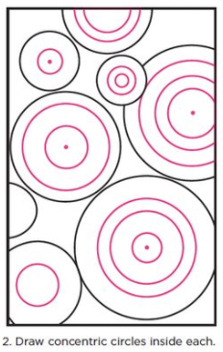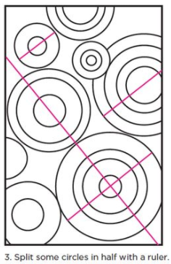  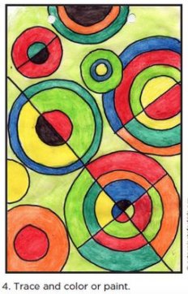  ART CHOICE #1: Concentric Circle Design  1. Fill the page with circles of all sizes (use bowls or container lids to trace).  2. Draw concentric circles inside each.  3. Split some circles in half with a ruler or straight edge of any kind.  4. Trace and color or paint circles.  TIP: The more lines you draw the more complex and detailed your art piece will be.  ART CHOICE #2: Shape Animal  1.Use shapes (traced from blocks or other items, or free draw shapes) to create an animal. You could also cut shapes from cereal boxes or other recyclables.  2. Think about what shape would best represent that part of the animal. Cut or draw the shapes to create the body and features.  3. Color in the animal with any materials you might have and even add a background or a habitat for your animal!  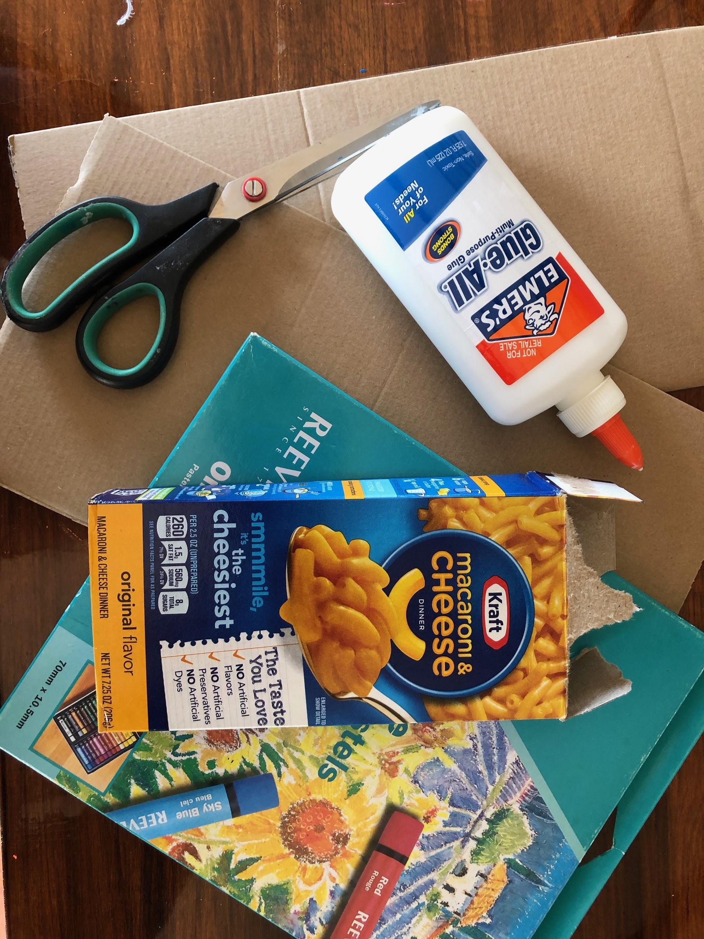  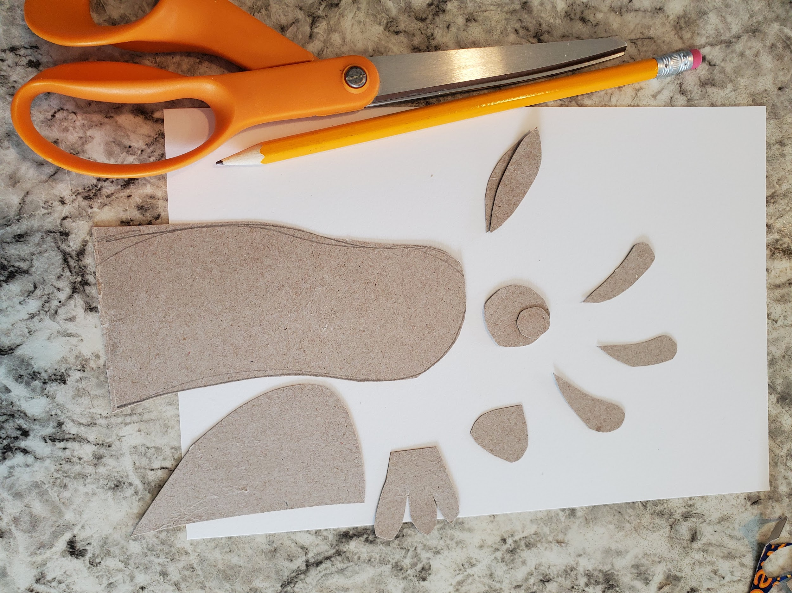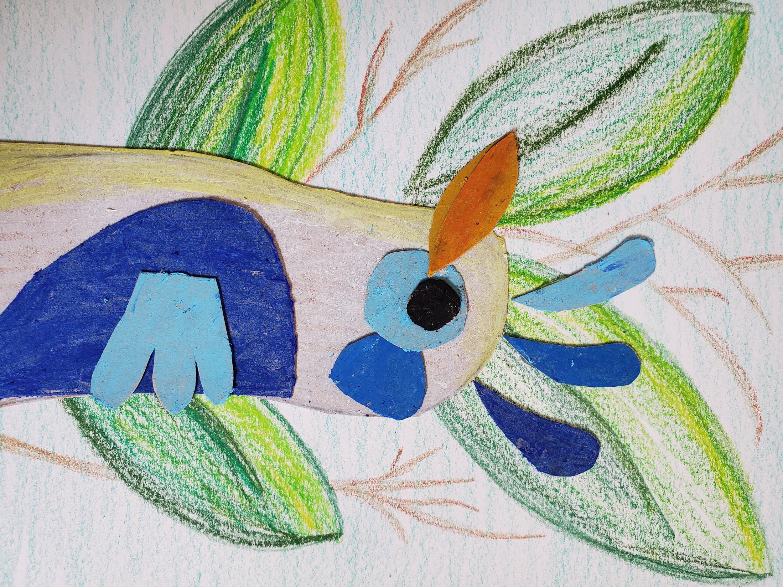 | BONUS RESOURCES  Want to learn more about SHAPE? Check out these ideas!  Geometric Quilt:  Cut circles from magazines and cut them into fractions. Glue fractions to create a symmetrical design.  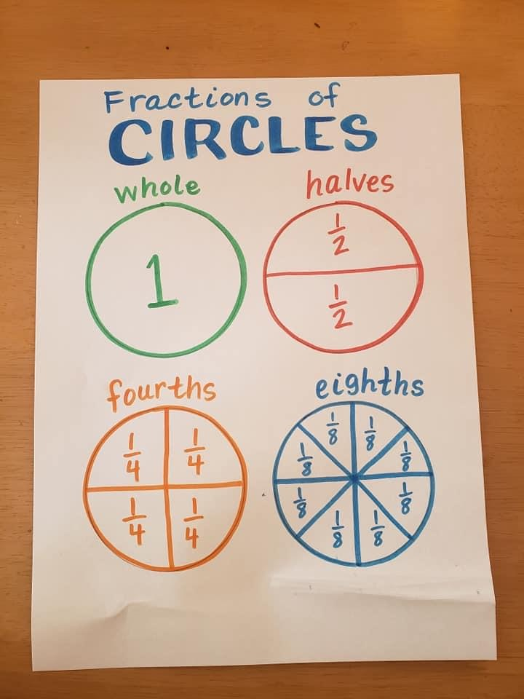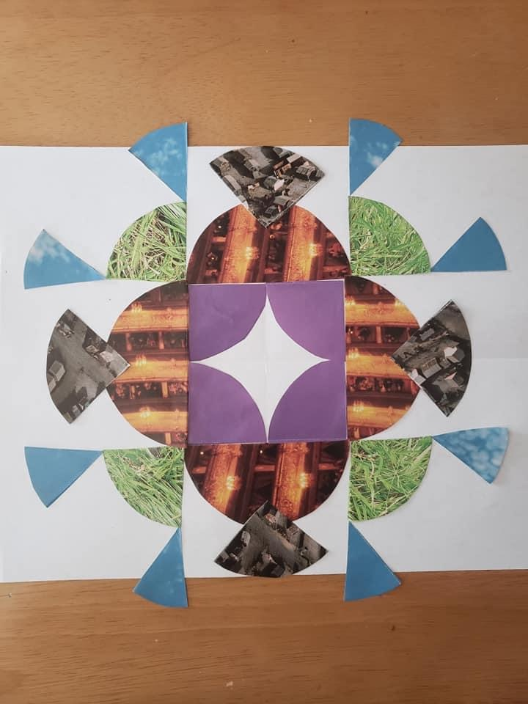  Shape Scavenger Hunt:  - Find something that turns that is a circle.  - Find something in the kitchen that is a square.  - Find something in your room that is a rectangle.  - Find something the shape of a heart.  - Find something the shape of a triangle.  - Find 3 things that are circles.  *Remember that you can use any different materials you might have at home, you do not have to use the same materials that I am using. Keep creating and use your imagination!

