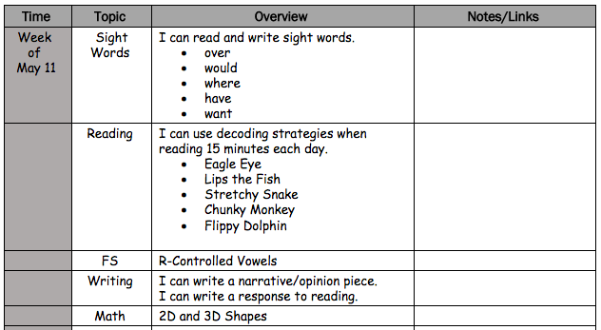

Weekly At-Home Learning Plan

Locust Lane Elementary

First Grade