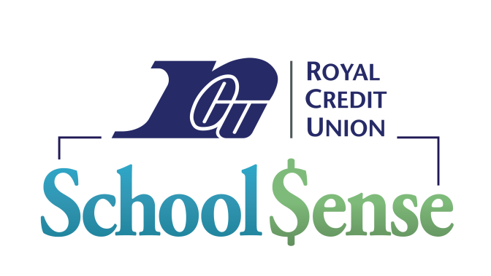

Dear Parents and Guardians:

Welcome to Kindergarten Orientation. What an exciting time for you and your new Kindergarten student! We are pleased to share information with you about the Locust Lane Royal Credit Union School $ense program.

Your school and Royal Credit Union have partnered to provide a valuable learning experience for all who choose to make saving money a fun and rewarding habit. By saving money, students are also helping their school. Locust Lane receives $250 from Royal every time 500 transactions are made at school.

Royal School $ense will be open mid-October 2023 through mid-May 2024. Below are details about how our program works:

* We will be open once a week starting in October. All students who have a Royal Credit Union savings account can take part in this exciting savings program!
* Student savings accounts can be opened online at *www.rcu.org/schoolaccounts* or at any Royal Credit Union office. Opening an account allows your student to use the school location along with any other Royal location. Every student can have an account with no minimum deposit! We make it simple to start an account…we even deposit the first $5.00!
* Students receive incentives for saving! Every fourth deposit earns the student a prize coupon which they can redeem at their School $ense location.

We look forward to another great school year at Locust Lane Elementary. The School $ense team and I are excited to meet your new Kindergartener! Please let me know if you have any questions.

Sincerely,

Rachel Orlovsky

Rachel Orlovsky

Financial Education Representative

rachel.orlovsky@rcu.org