Be aware, wash with care!

There are many types of germs (viruses, bacteria, parasites, fungi) that cause many types of illnesses. These germs can spread easily from one person to another and have wide-reaching effects.
One of the most common ways people catch colds is by rubbing their noses or eyes after touching someone or something that's contaminated with the cold virus. Nearly 22 million school days are lost annually due to the common cold.
A study involving Detroit school children showed that scheduled handwashing, at least four times a day, can reduce gastrointestinal illness and related absences by more than 50%.
Handwashing with soap and water is the most effective and inexpensive way to prevent illness.
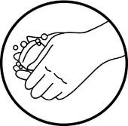
As winter season is approaching, remember the importance of handwashing. Please remind your children and model good habits.
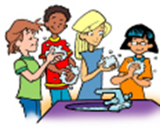
http://www.itsasnap.org/snap/handwashing.htm

