Fall 2022 North Cross Country: REMIND 101 SIGN-UP INFORMATION
*Use either of the sign-up methods below to get signed up for this seasons’ Remind 101*
OPTION #1: Text the Class Code to sign-up
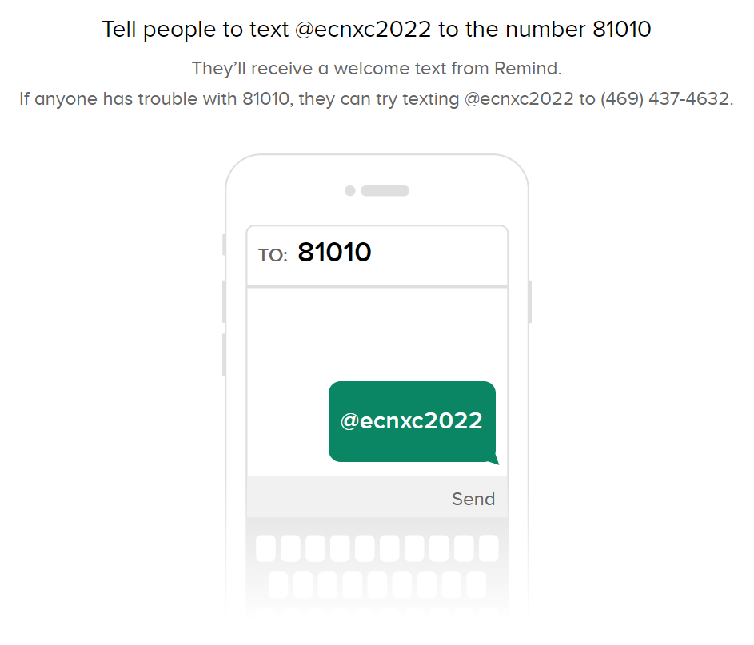
OPTION #2: Type in the direct link and sign-up
