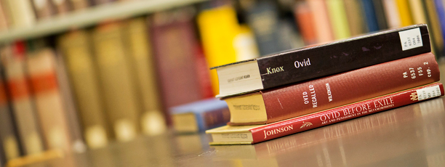

Return Overdue Library Items

Please bring all books and textbooks from last school year back to school: math textbooks, Reading class novels, library books, atlases. We’ll take it all!

We’re also happy to take back books from any school – elementary schools, DeLong, or South! We’ll check it in, get it off your library account and send it back to your old school. Now is the time to return items before we start printing off overdue notices. Return overdue books to your core teachers or drop them off in the hall return slot just outside the library doors.
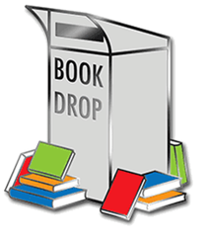

Thank you!

